
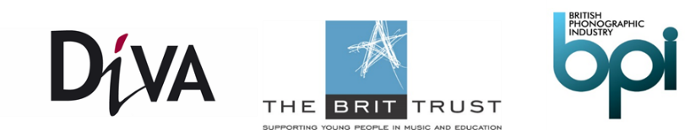
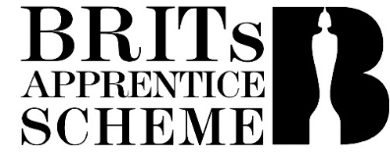

HOST COMPANY APPLICATION FORM

About the Programme

The BRIT Trust Apprenticeship Programme (“Programme”) delivered in partnership with the BPI and DiVA Apprenticeships is a nationwide scheme that matches the next generation of music industry talent to current staff shortages across the music business.

The aim of the programme is to give up to ten young people from disadvantaged and diverse backgrounds an exciting, high quality opportunity to fast track their career in the music industry and at the same time provide a cost-effective solution to those host companies looking for an extra pair of hands for a sustained period – 15 months.

The typical job roles suited to an apprenticeship are support roles in marketing, administration, digital media, business affairs, licensing and A&R.

If you are interested in becoming a host company, please read the associated FAQ sheet before completing this form.

Completed forms should be returned to apprenticeships@bpi.co.uk no later than 5pm on 4th May 2021.

The BRIT Trust will fully fund the training and provide 2/3rd of the apprentice’s salary. The host company will provide the apprenticeship placement and the remaining 1/3rd of the apprentice’s salary, which will be £7,500 or £6,250 for the duration of the apprenticeship (15 months) per apprentice depending on where they are based (London or ex-London respectively).

Apprentices are scheduled to commence their apprenticeships from November 2021.

To pledge your interest in becoming a Host Company, please return this form to apprenticeships@bpi.co.uk by 4th May 2021.

About your business

Company Name | Telephone:
Company Address | Email:
Number of employees (exc freelance staff) | Have you hired an apprentice in the last 12 months? (delete as appropriate)  Yes No
Is your business subject to the Apprenticeship Levy? (delete as appropriate) The Apprenticeship Levy is a 0.5% tax that is payable by companies who have an annual payroll of £3million and above.

Yes No

If you have answered “Yes” to the question above, please confirm the amount of Levy your organisation pays each year.

Do you have Employers’ Liability Insurance that is current and other insurance is in place, as appropriate to the business undertaking. | Insurers name  Policy Number  Expiration date
Apprentices are required to be employed directly by you as the Host Company. Please confirm whether you have the following in place.

□ Health and Safety Policy
□ Disciplinary Policy
□ Grievance Policy
□ Equal Opportunity Policy
□ Diversity Statement
□ Contract of Employment
□ GDPR Compliance Policy
□ COVID Risk Assessment

Note: if required companies selected will receive support and guidance from DiVA to put the above in place.
Please provide a brief description of your organisation (no more than 300 words)

Please use this section to provide an outline of the apprenticeship you would like to offer. You must include clear details about the following
- What is the role including title i.e. digital marketing assistant?
- What are the key responsibilities and duties you would expect the apprentice to do?
- What’s the department, area or team that the vacancy applies to?
- How the role fits within the organisation?
- Will the position be remote / onsite or blended?
- How will you further support the development of your apprentice?

Please provide details of the senior member of staff who will manage the Apprentice. Line Managers will be required to attend an induction on ‘Managing Apprentices’ with DiVA. This induction is currently scheduled to take place in September 2021.

Name_____________________________________ Position _______________________________

Does the individual have management experience?

Yes No

Declarations

By signing this document, you accept and agree with the following statements:

I understand and agree that there will be a named manager who will be responsible for looking after the apprentice, who will attend an induction on ‘Managing Apprentices’ and who will meet with the training manager four times during the Apprenticeship to discuss how the placement is working.

I understand and agree that the apprentice will spend 20% of their time engaged in ‘off the job’ training which will be organised by DiVA.

I understand and agree that we will pay for 1/3 of the Apprentice’s salary and that the BPI will pay for the other 2/3 and that we will be required to enter into agreements with the BPI and DiVA (through All Spring Media) detailing our obligations in respect of the Programme and our receipt of the payment.

I confirm that I have all necessary permissions to share such personal data with BPI and DiVA and consent to BPI and DiVA holding and processing the personal data I provide in connection with this application; such processing shall include, but not be limited to, organising and administering the Programme. BPI and DiVA shall ensure that they process the data in compliance with their obligations under the Data Protection Act 2018 and other applicable privacy legislation or regulation and shall not do anything that causes them to breach such legislation or any other applicable privacy laws or regulations.

Should [insert company name] _______________________ be selected as a host company to deliver an apprenticeship we confirm our contribution as outlined above and that we will enter into an employment agreement with the Apprentice on fair and reasonable terms for the duration of the Apprenticeship.

Name of person completing the form

Job Title

Date

DiVA has merged its apprenticeship business with All Spring Media. Although the company remains a legal entity in its own right, contracts and training will be delivered under the umbrella of All Spring Media. This will not affect your continued relationship with DiVA Apprenticeships, this note merely informs you of procedural changes.
DiVA has merged its apprenticeship business with All Spring Media. Although the company remains a legal entity, contracts and training will be delivered under the umbrella of All Spring Media. This will not affect your continued relationship with DiVA Apprenticeships, this note merely informs you of procedural changes.

